PROJECT

ART GALLERY MANAGEMENT SYSTEM

4/28/2025

ART GALLERY MANAGEMENT SYSTEM

1. Introduction
The Art Gallery Management System is a database-driven application designed to manage and organize the operations of an art gallery efficiently. The system focuses on structured data storage, strong relational modeling, and normalization to ensure accuracy, consistency, and minimal redundancy.
This system manages key entities such as galleries, artists, artworks, employees, exhibitions, and customers, along with their relationships.

2. Objectives
- To design a well-structured relational database
- To eliminate redundancy through normalization (1NF–3NF)
- To maintain data integrity using primary and foreign keys
- To handle real-world relationships (1:N and M:N)
- To provide a simple interface for data interaction

3. Scope of the System
The system covers:
- Managing gallery details
- Tracking employees and their roles
- Maintaining artist and artwork records
- Organizing exhibitions
- Handling customer orders
- Managing artwork sales

4. System Entities
The system includes the following main entities:
- Art_Gallery
- Employee
- Artist
- Artwork
- Exhibition
- Artwork_Exhibition (Junction Table)
- Customer
- Order
- Order_Details

PROJECT ERD
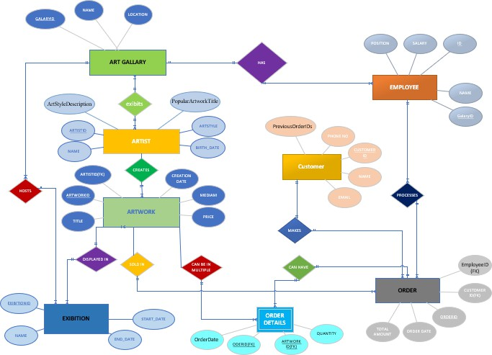

Relational Model
- Art_Gallery
CREATE TABLE Art_Gallery ( GalleryID INT PRIMARY KEY, Name VARCHAR(100) NOT NULL,
Location VARCHAR(100) NOT NULL
);
- Employee
CREATE TABLE Employee (
ID INT PRIMARY KEY,
Name VARCHAR(100) NOT NULL, Position VARCHAR(50) NOT NULL, Salary DECIMAL(10,2) NOT NULL, GalleryID INT NOT NULL,
FOREIGN KEY (GalleryID) REFERENCES Art_Gallery(GalleryID)
);
- Artist
CREATE TABLE Artist (
ArtistID INT PRIMARY KEY,
Name VARCHAR(100) NOT NULL, ArtStyle VARCHAR(50),
Birth_Date DATE,
ArtStyleDescription VARCHAR(255),

PopularArtworkTitle VARCHAR(100)
);
- Artwork
CREATE TABLE Artwork ( ArtworkID INT PRIMARY KEY, Title VARCHAR(100) NOT NULL,
Creation_Date DATE, Medium VARCHAR(50), Price DECIMAL(10,2), ArtistID INT NOT NULL,
FOREIGN KEY (ArtistID) REFERENCES Artist(ArtistID)
);
- Exhibition
CREATE TABLE Exhibition ( ExhibitionID INT PRIMARY KEY, Name VARCHAR(100) NOT NULL,
Start_Date DATE NOT NULL, End_Date DATE NOT NULL
);
- Artwork_Exhibition
CREATE TABLE Artwork_Exhibition ( ArtworkID INT NOT NULL, ExhibitionID INT NOT NULL,
PRIMARY KEY (ArtworkID, ExhibitionID),
FOREIGN KEY (ArtworkID) REFERENCES Artwork(ArtworkID), FOREIGN KEY (ExhibitionID) REFERENCES Exhibition(ExhibitionID)
);
- Customer
CREATE TABLE Customer ( CustomerID INT PRIMARY KEY, Name VARCHAR(100) NOT NULL, Phone_No VARCHAR(20),
Email VARCHAR(100),
PreviousOrderIDs VARCHAR(255)
);
- Order
CREATE TABLE Order ( OrderID INT PRIMARY KEY,
OrderDate DATE NOT NULL, TotalAmount DECIMAL(10,2) NOT NULL,
CustomerID INT NOT NULL, EmployeeID INT NOT NULL,
FOREIGN KEY (CustomerID) REFERENCES Customer(CustomerID),

FOREIGN KEY (EmployeeID) REFERENCES Employee(ID)
);
- Order_Details
CREATE TABLE Order_Details ( OrderID INT NOT NULL, ArtworkID INT NOT NULL, OrderDate DATE INT NOT NULL,
Quantity INT NOT NULL,
PRIMARY KEY (OrderID, ArtworkID),
FOREIGN KEY (OrderID) REFERENCES Order(OrderID),
FOREIGN KEY (ArtworkID) REFERENCES Artwork(ArtworkID)
);
- Normalize the relations (1NF → 2NF → 3NF)

- Art_Gallery table

1NF (First Normal Form) Analysis Requirements:
  - All columns contain atomic (indivisible) values
  - Each record (row) is unique

Analysis:
- GalleryID, Name, and Location all contain atomic values
- No composite values or repeating groups
- Each row is uniquely identified by GalleryID (primary key)
- No multi-valued attributes
Conclusion: The table is already in 1NF. 2NF (Second Normal Form) Analysis Requirements:
- Must be in 1NF
- All non-key attributes must be fully functionally dependent on the entire primary key

Analysis:

- Primary key is GalleryID (single-column key)
- Non-key attributes are Name and Location
- Both Name and Location are properties that describe the gallery entity
- Both attributes depend entirely on the GalleryID (the entire primary key)
- No partial dependencies possible since the primary key is not composite
Conclusion: The table is already in 2NF. 3NF (Third Normal Form) Analysis Requirements:
- Must be in 2NF
- No transitive dependencies (non-key attributes must not depend on other non-key attributes)

Analysis:
- Non-key attributes are Name and Location
- There is no functional dependency between Name and Location
  - A gallery's name doesn't determine its location
  - A gallery's location doesn't determine its name
- Both attributes depend only on the primary key (GalleryID)
- No transitive dependencies exist
Conclusion: The table is already in 3NF.

Employee table
1NF (First Normal Form) Analysis Requirements:
- All columns contain atomic (indivisible) values
- Each record (row) is unique

Analysis:

- ID, Name, Position, Salary, and GalleryID all contain atomic values
  - No composite values or repeating groups
- Each row is uniquely identified by ID (primary key)
- No multi-valued attributes
Conclusion: The table is already in 1NF. 2NF (Second Normal Form) Analysis Requirements:
- Must be in 1NF
- All non-key attributes must be fully functionally dependent on the entire primary key

Analysis:
- Primary key is ID (single-column key)
- Non-key attributes are Name, Position, Salary, and GalleryID
- All attributes describe properties of an employee
- All attributes depend entirely on the ID (the entire primary key)
- No partial dependencies possible since the primary key is not composite

Potential Consideration:
- If Salary was determined by Position alone (not by employee), this would create a dependency
- However, in this model, salary is an employee-specific attribute (two employees with same position could have different salaries)
Conclusion: The table is already in 2NF. 3NF (Third Normal Form) Analysis Requirements:
- Must be in 2NF

- No transitive dependencies (non-key attributes must not depend on other non-key attributes)

Analysis:
- Non-key attributes are Name, Position, Salary, and GalleryID
- Possible dependencies to check:
- Does Position determine Salary? (No - employees in same position may have different salaries)
- Does GalleryID determine any other attribute? (No)
- Does Position determine GalleryID? (No - same position could exist in multiple galleries)
- All attributes depend only on the primary key (ID)
- No transitive dependencies exist
Conclusion: The table is already in 3NF.

Artist table
1NF (First Normal Form) Analysis Requirements:
  - All columns contain atomic (indivisible) values
  - Each record (row) is unique

Analysis:
  - ArtistID, Name, ArtStyle, Birth_Date, ArtStyleDescription, and PopularArtworkTitle all contain atomic values
  - No composite values or repeating groups
  - Each row is uniquely identified by ArtistID (primary key)
  - No multi-valued attributes
Conclusion: The Artist table is already in 1NF.

2NF (Second Normal Form) Analysis Requirements:
  - Must be in 1NF
  - All non-key attributes must be fully functionally dependent on the entire primary key

Analysis:
  - Primary key is ArtistID (single-column key)
  - Non-key attributes are Name, ArtStyle, Birth_Date, ArtStyleDescription, and PopularArtworkTitle
  - All attributes describe properties of the artist entity
  - All attributes depend entirely on the ArtistID (the entire primary key)
  - No partial dependencies possible since the primary key is not composite

Potential Issue:
  - ArtStyleDescription appears to be functionally dependent on ArtStyle rather than directly on ArtistID
  - This suggests a possible transitive dependency (more relevant for 3NF analysis)
Conclusion: The table is in 2NF.

Recommendations for Normalization:
- Create a separate ArtStyle table
CREATE TABLE ArtStyle (
ArtStyle VARCHAR(50) PRIMARY KEY,
Description VARCHAR(255) NOT NULL
);
- Modify the Artist table:
CREATE TABLE Artist (

ArtistID INT PRIMARY KEY,
Name VARCHAR(100) NOT NULL, ArtStyle VARCHAR(50),
Birth_Date DATE,
FOREIGN KEY (ArtStyle) REFERENCES ArtStyle(ArtStyle)
);
- For PopularArtworkTitle, consider:
  - Removing it if it's volatile data

Artwork Table 1NF Analysis:
- All columns contain atomic values
- Each row is uniquely identified by ArtworkID
- No repeating groups or composite values Conclusion: Already in 1NF

2NF Analysis:
- Primary key is ArtworkID (single-column)
- All non-key attributes (Title, Creation_Date, Medium, Price, ArtistID) depend fully on ArtworkID
Conclusion: Already in 2NF

3NF Analysis:
- No transitive dependencies found
- All non-key attributes depend only on the primary key Conclusion: Already in 3NF

Exhibition Table 1NF Analysis:
- All values atomic

- ExhibitionID uniquely identifies each row Conclusion: Already in 1NF

2NF Analysis:
- Single-column primary key
- All attributes depend fully on ExhibitionID Conclusion: Already in 2NF

3NF Analysis:
- No transitive dependencies Conclusion: Already in 3NF
- Artwork_Exhibition Table 1NF Analysis:
- Composite primary key (ArtworkID, ExhibitionID)
- All values atomic
Conclusion: Already in 1NF

2NF Analysis:
- All attributes are part of the key (no non-key attributes) Conclusion: Automatically in 2NF

3NF Analysis:
- No non-key attributes to analyze Conclusion: Already in 3NF

Customer Table 1NF Analysis:
- All values atomic except potentially PreviousOrderIDs
- If PreviousOrderIDs stores multiple order IDs in one field (e.g., "123,456,789"), this violates 1NF
Problem: PreviousOrderIDs may contain multiple values

2NF Analysis:

- Cannot be assessed until 1NF violations are resolved

3NF Analysis:
- Cannot be assessed until 1NF violations are resolved

Recommendation:
- Remove PreviousOrderIDs from Customer table
- Track order history through the Order table relationships

Correct Tbale
CREATE TABLE Customer (
CustomerID INT PRIMARY KEY,
Name VARCHAR(100) NOT NULL, Phone_No VARCHAR(20),
Email VARCHAR(100)
-- PreviousOrderIDs removed completely
);

Order Table 1NF Analysis:
- All values atomic
- OrderID uniquely identifies each row Conclusion: Already in 1NF

2NF Analysis:
- Single-column primary key
- All attributes depend fully on OrderID Conclusion: Already in 2NF

3NF Analysis:
- Potential issue: TotalAmount could be calculated from Order_Details
- Consider removing TotalAmount as it's derivable

Recommendation:
- Remove the TotalAmount column from the Order table
- Calculate the total amount dynamically when needed through queries or views
Corrected Schema:
CREATE TABLE Order ( OrderID INT PRIMARY KEY,
OrderDate DATE NOT NULL, CustomerID INT NOT NULL, EmployeeID INT NOT NULL,
FOREIGN KEY (CustomerID) REFERENCES Customer(CustomerID), FOREIGN KEY (EmployeeID) REFERENCES Employee(ID)
-- TotalAmount removed completely
);
- Order_Details Table 1NF Analysis:
- All values atomic
- Composite primary key (OrderID, ArtworkID) Conclusion: Already in 1NF
2NF Analysis:
- Issue: OrderDate depends only on OrderID (partial dependency)
- Violates 2NF because non-key attribute depends on part of composite key Problem: OrderDate should not be in this table
3NF Analysis:

- Cannot be assessed until 2NF violations are resolved

Recommendation:
- Remove OrderDate from Order_Details
- Access order date through the Order table instead,
Corrected table
CREATE TABLE Order_Details ( OrderID INT NOT NULL, ArtworkID INT NOT NULL, Quantity INT NOT NULL,
PRIMARY KEY (OrderID, ArtworkID),
FOREIGN KEY (OrderID) REFERENCES Order(OrderID),
FOREIGN KEY (ArtworkID) REFERENCES Artwork(ArtworkID)
-- OrderDate removed completely
);

After Normalization ERD

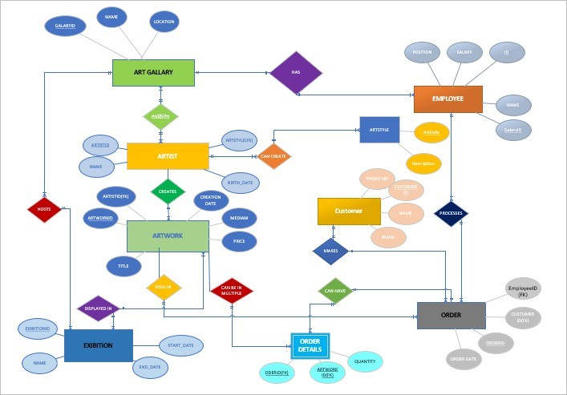

8. System Features
- Structured database with relationships
- Supports complex queries
- Maintains referential integrity
- Efficient storage and retrieval
- Scalable design

9. Tools & Technologies
- DBMS: MySQL / SQL Server
- Language: SQL
- Frontend (basic): HTML/CSS ,Php

10. Conclusion

The Art Gallery Management System successfully demonstrates a strong understanding of:
- Relational database design
- Entity relationships
- Data normalization (1NF–3NF)
- Real-world system modeling

The system ensures data consistency, reduced redundancy, and efficient data management, making it suitable for real-world gallery operations.

